EXPERIMENT-6
Aim
To develop a cloud-based Product Selling Application using Zoho Creator that allows customers to order products online and stores order details in the cloud.
Software Used
- Zoho Creator
- Web Browser (Chrome/Edge)
- Zoho Cloud Platform
Algorithm
- Open Zoho Creator.
- Create a new application named Product Selling System.
- Add the required fields.
- Enter customer and product details.
- Click Submit.
- Store order details in the cloud database.
- Display order confirmation.
Output:
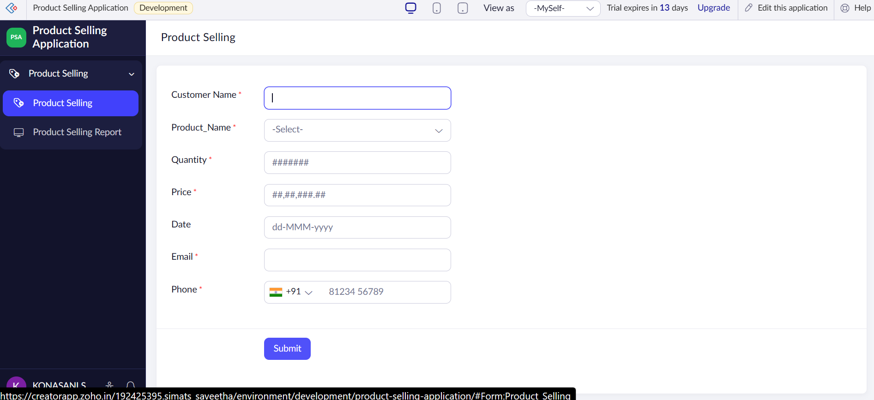
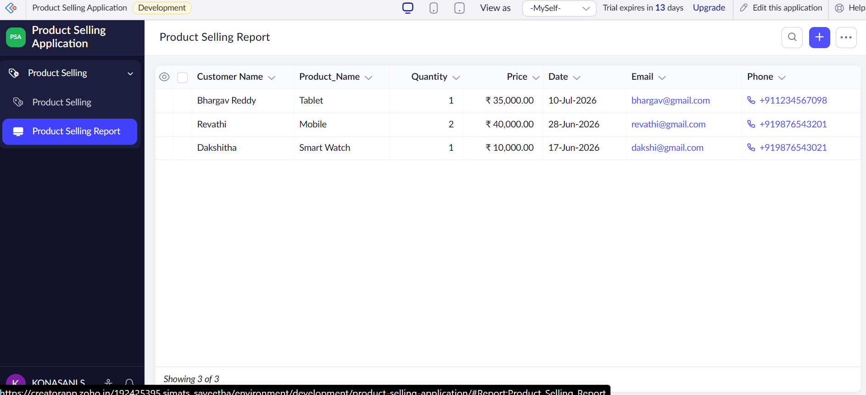

Result
The Product Selling Application was successfully developed using Zoho Creator SaaS. The system allows customers to place product orders online, stores order details in the cloud, and provides order confirmation.

